# PROJECT PLANNING TOOLS

|  |  |
| --- | --- |
| Date | 18 October 2022 |
| Team ID | PNT2022TMID22747 |
| Project Name | Project - Visualizing and Predicting Heart Diseases with an Interactive Dash Board |
| Maximum Marks | 2 Marks |

Project management is not a straightforward science, as we all know. It is an intricate synthesis of many different ideas, from strategy to people management, IT communications to figure crunching.This article will teach us about the most crucial resources available to managers. They are used to plan or schedule tasks for projects, identify critical paths, keep track of progress, and do all other crucial duties required for a smooth project cycle.

Critical Path Method

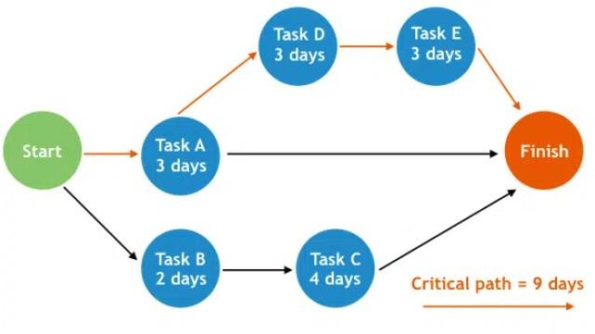

# Gantt Charts

A Gantt chart is a diagram that shows all the jobs that are planned to be completed late for your project. Plans for projects of all sizes and kinds are made using them.

